# Sprint Review Notes Template

**Group**: Group 13

**Sprint:** Sprint 1

**Date:** 15 August 2020

**Attended:**

**Scrum Master:**Shiyu Chen

**Product Owner:**Noureddine Dib

**Scrum team:**Shiyu Chen,QingZhao Liu, Jerome Youssef, Hanwu Yu, HaoMing Tian

**Client Name:** BFit

## 1- What was the goal for this sprint? (Product Owner)

Intro about the goal

Product road-map review

Any impact of this sprint on release plan

The goal of this sprint 1 is to have a quick start of our project which is to design and analysis the whole project and to set up scenario of first two feature of the whole project(C1 and A2), in order to create and improve the future development of these two feature. The planning and design is a important part for programmer, which helps the programmers to understand the requirements easily, in other to work efficiently.

For Custromers, the main goal for this sprint 1 is to design the feature that allows customer to do the fitness tracking.

For Adim, the main goal for this sprint 1 is to design the feature that allows Admin to manage training program.

Therefore, we have set up three user stories for each feature.

The Product road-map review:

This sprint will help the whole team to develop the project step by step, which means the team can do the improve and changes before they start the next design/coding. Also as a new team, the group can get familar with others to work together in a better way.

## 2- Review of the requirement (Product Owner)

Review top three user stories related to the sprint goal

As a Customer

I want to have the ability to be able to enter workouts.

so that customers will be able to review their workout sessions, so they can later review it or share it with a personal trainer, to help improve their quality and efficiency in workouts in the future.

As a Bfit staff member

I want to Create new program，

so that Customers can enroll in training programs.

As a Customer

I want to be able to view my overall progress made since I joined the app，

so that I will be able to learn from my patterns and review if I want to maintain what I’m doing or increase/decrease my workout habits.

These three User Stories maybe the most important for the project that is the basic feature of the project.

## 3- Sprint status (Scrum Master)

Plan vs Reality

Review sprint statistics (story points left, story points done, planned story points, story points per person)

Statistic of release

In the team communication, the group have a meetting at 15 Ausust, about 48 minutes to discuss the job delivery.



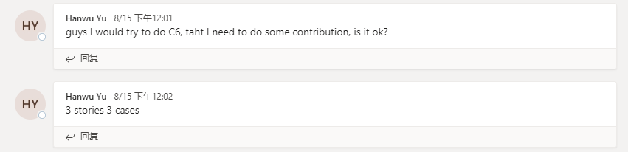

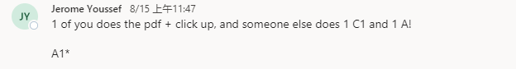

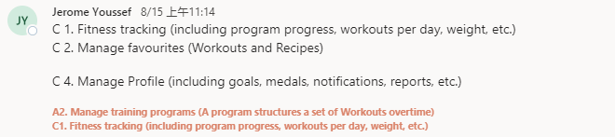



Shiyu:

Then we decide to upload our works before the tutorial strat which is on 19 August.

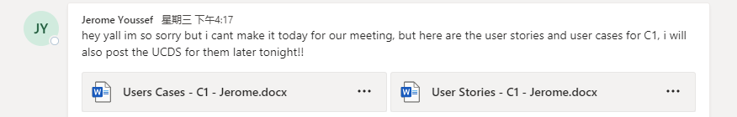

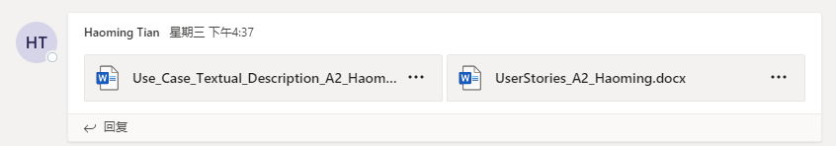

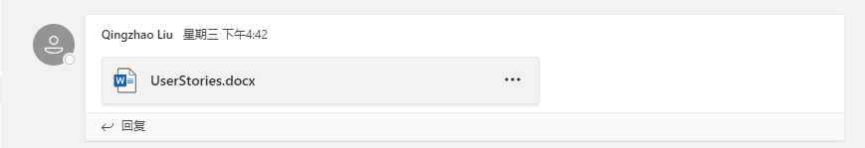

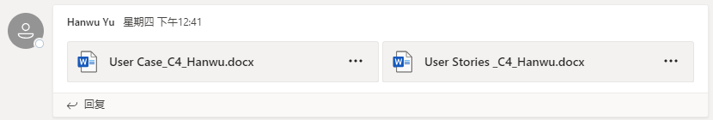

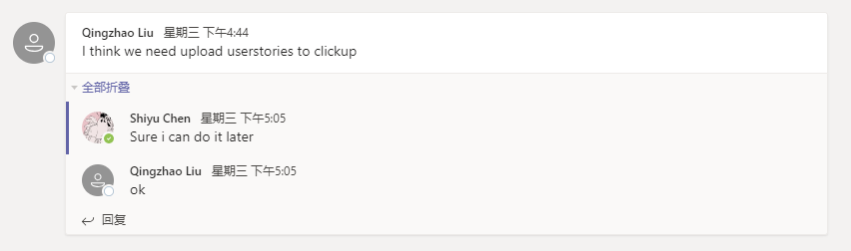

Review important technology improvement or change:

In this sprint, we use LucidChart to work on our User Case Diagram together, and use Microsoft Team for communicates. Then Use ClickUp and Github to upload the works for everyone in the group can edit it.

Status of bugs ( how many fixed)

We found that we have a misunderstanding about the requirements of our Sprint 1. So that Shiyu has point it out then we start to fix it together.

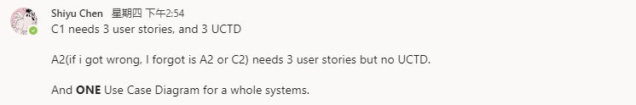

## 4- Customer Feedback (Client)

Note down client's feedback

* The deisgn is make very simple to read
* Match the requirements
* But it is too simple that they might not be able to image the final performance.

## 5- Closing (Team)

Discussion on next sprint review and goal

In the next Sprint, we maybe work on develop these two features and to design more features in the project. So that we should learn the mistake of this Sprint so that we can improve in the next Sprint:

* Time management

- Our progress were slow, we should do it quicker.

* Planning

- The planning wasn’t that good so we done some useless stuff.

* Analysis the requirements

- Analysis is important to reduce the time waste.

* Communications

- Sometimes the members can’t see the message. So that we can’t talk about the project.